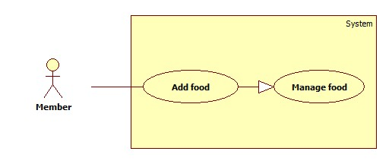

**Use Case Specification**

|  |  |  |  |
| --- | --- | --- | --- |
| **USE CASE - M01** | | | |
| **Use Case No.** | M01 | **Use Case Version** |  |
| **Use Case Name** | Add food | | |
| **Author** | Truong Thanh Lam | | |
| **Date** | 25/01/2016 | **Priority** | High |
| **Actor:**   * Member   **Summary:**   * This use case allows members to add food   **Goal:**   * Member can add food to his/her fridge   **Triggers:**   * Member sends Add food command   **Preconditions:**   * Actor must logged in with role Member   **Post Conditions:**   * Success: New food is added to the system * Fail: Error message is shown   **Main Success Scenario:**   |  |  |  | | --- | --- | --- | | **Step** | **Actor Action** | **System Response** | | **1** | Member goes to Add food view | System shows view and requires new food information:  - Name: free text input, required, length [2,30]  - Quantity: free text input, integer value [1,1000]  - Unit: choose from list  - Expired date: date, required,  - Notification date: number, required. (default value is 3). | | **2** | Member inputs new food information  [Alternative 1] |  | | **3** | Member sends Add food command | New food is added to the system  [Exception 1, 2] |   **Alternative Scenario:**   |  |  |  | | --- | --- | --- | | **No** | **Actor Action** | **System Response** | | **1** | Member selects Scan barcode option | System activates camera to scan food’s barcode |   **Exception**   |  |  |  | | --- | --- | --- | | **No** | **Cause** | **System Response** | | **1** | Member sends Add food command with invalid inputted data  - Ghi cụ thể nguyên nhân (chiều dài ko đủ…) | System shows error message (ghi cụ thể nội dung message) | | **2** | There is no Internet connection  (ko ghi rủi ro kỹ thuật) | Inputted data is cached. Those data are then synchronized when connection is gained.  System shows error message to notify Member. |   **Relationships: N/A**  **Business Rules:**   * Unit can be kilogram, gram, can, bottle, piece, box... or user manually input. * Unit is only available if quantity is inputted * If barcode is recognized, food name will be automatically filled | | | |

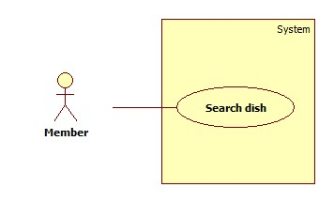

**Use Case Specification**

|  |  |  |  |
| --- | --- | --- | --- |
| **USE CASE - M01** | | | |
| **Use Case No.** | M02 | **Use Case Version** |  |
| **Use Case Name** | Search dish | | |
| **Author** | Truong Thanh Lam | | |
| **Date** | 25/01/2016 | **Priority** | Normal |
| **Actor:**   * Member   **Summary:**   * This use case allows members to search dishes by name   **Goal:**   * Member can search for dishes   **Triggers:**   * Member changes text in search field   **Preconditions:**   * Actor must logged in with role Member * *Dishes existed in the system*   **Post Conditions:**   * Success: Search result is shown * Fail: *Error message is shown (N/A)*   **Main Success Scenario:**   |  |  |  | | --- | --- | --- | | **Step** | **Actor Action** | **System Response** | | **1** | Member goes to Search dish view | System shows view and requires search text | | **2** | Member inputs dish name | System searches dishes based on name and displays result |   **Alternative Scenario: N/A**  **Exception**   |  |  |  | | --- | --- | --- | | **No** | **Cause** | **System Response** | | **1** | There is no Internet connection | System shows error message to notify Member. |   **Relationships:**   * Add favorite dish * View recipe   **Business Rules:**   * Search is triggered automatically whenever text in search field changes * Search result contains dishes’ names and options for Member to Add favorite dish, View recipe | | | |